

COLLEGE CATALOG 2026

THE COLLEGE CATALOG IS PUBLISHED BY THE AMERICAN UNIVERSITY OF ANTIGUA COLLEGE OF ARTS AND SCIENCES FOR ALL ENROLLED STUDENTS.

The rules and regulations outlined here are binding and must be adhered to by all AUACAS students, including those on leave. The rules and regulations of this institution are reviewed and revised periodically. Students are expected to be familiar with the most recent revisions of all manuals and publications, which can be found at the AUACAS website.

OFFICERS AND STAFF
STATEMENT OF CORPORATE ORGANIZATION AND LEGAL CONTROL

The American University of Antigua College of Arts and Sciences, Inc. is owned by American University of Antigua, Inc. The latter is owned by Manipal Education Americas, LLC.

The College is organized as a corporation under the laws of Antigua and Barbuda with the following officers:

President: Peter Bell
Secretary: Vernon Solomon

GOVERNANCE

President: Peter Bell
Dean of the College: Jorge A. Moreno

ADDRESS
American University of Antigua College of Arts and Sciences
P.O. Box W-1451 University Park, Coolidge St. John’s, Antigua, W.I.
Telephone: 268-484-8900, Ext. 2000, 2001, 2014
Webpage: www.auacas.org

ACCREDITATIONS

Accredited by the Antigua and Barbuda National Accreditation Board.

PURPOSE OF THE CATALOG
This Catalog provides prospective students, currently enrolled students and others information about the American University of Antigua College of Arts and Sciences, especially its academic programs and student support services. The Catalog contains summaries of college policies for academic areas, degree requirements, descriptions of support services and course listings.

Although faculty advisors and administrators will help students meet the requirements for a degree, the students are responsible for fulfilling requirements. The degree will be awarded only if all requirements have been met. It is important that students know the policies, requirements, ,and procedures which they are expected to follow during their college career.

ADMINISTRATIVE STAFF

Executive Assistant to the Dean Ann-Marie Liverpool
(aliverpool@auacas.net)

Faculty Assistant Youland Morris
(ymorris@auacas.net)

ACADEMIC SUPPORT STAFF

Chief Laboratory Technician Adriel Joseph

FACULTY

Pugazhandhi Bakthavatchalam, Ph.D.
Ph.D Neuroanatomy (Melaka Manipal Medical College 2023)
M.Sc (Medical Anatomy) Kasturba Medical College Manipal (2011)
B.Sc (Medical Lab Technology) Pondicherry University Puducherry India (2006)
Assistant Professor of Anatomy
Subjects Taught: Anatomy and Physiology
pbakthavatchalam@auacas.net

Ashby, Janet, Ph.D.
Ph.D. Chemistry (Leicester Polytechnic, U.K.,1990) B.Sc. Chemistry (Leicester University, 1984) Assistant Professor of Chemistry
Subjects Taught: General Chemistry jashby@auacas.net

Ashiboe-Mensah, Sandra, M.Sc.
M.Sc. Medical Microbiology, (University of the West Indies, 2015)
B.Sc. Biochemistry (Kwame Nkrumah University of Science and Technology, Ghana, 2003)
sashiboe-mensah@auacas.net

Austin-McDonald, Ananthsa, BSc.
BSc. Health Sciences (American University of Antigua College of Medicine,
amcdonald@auacas.net

Isaacs, Elton, M.B.A.
MBA (University of the West indies, 2008)
B.Sc. Biology (University of Guyana, 1992)
Subjects Taught: Economics
eisaacs@auacas.net

Moreno, Jorge A., Ph.D.
Ph.D. Biology (University of Colorado, Boulder, 1994)
B.S. General Studies (Cornell University, 1977) Professor of Biology
Subjects Taught: Introductory Biology, Genetics
jmoreno@auacas.net

Ramsey, Janet A., M.A.
M.A. Applied Linguistics and Bilingualism (University of Newcastle Upon Tyne, U.K., 1996)
B.A. (Hons.) Modern Languages (University of Westminster, UK, 1995) Instructor of Languages
Subjects Taught: Spanish, English
jramsey@auacas.net

Spencer, Malverne, Ph.D.
Ph.D. Chemistry (University of the West Indies, 2002)
M.Sc. Forensic Science (University of Strathclyde, 1989)
B.Sc. Chemistry (University of the West Indies, 1982) Assistant Professor of Chemistry
Subjects Taught: Organic Chemistry mspencer@auacas.net

Ngorosha Loveness, Ph.D
Ph.D. Philosophy (University of Miami 2024)
M.Sc. Family and Child Studies (University of Miami, 2015)
B.A. Education (Solusi University Zimbabwe, 2006)
Instructor of Learning Strategies
Subjects Taught: Learning Strategies
lngorosha@auacas.net

HISTORY OF THE AMERICAN UNIVERSITY OF ANTIGUA COLLEGE OF ARTS AND SCIENCES

The American University of Antigua College of Arts and Sciences commenced as a program within the American University of Antigua (AUA) in August 2004. The AUA program aimed to provide high school graduates with a university-level curriculum which prepared them for entry into U.S.-style medical schools, including the American University of Antigua’s (AUA) College of Medicine.

The curriculum included pre-requisite courses and credit hours typically expected for entry into
U.S. medical schools and required by the Medical Licensing Board of New York State, where AUA was first approved for clinical clerkships and residency. Admission to the program required a minimum high school GPA and evidence of high school completion. Students were also able to transfer into the program to complete missing pre-requisites.

The AUA program accepted its first cohort of five students in the Fall 2004 semester. All students who initially applied chose to enter AUA’s College of Medicine, although a few applied to other medical schools after completing their course work.

By 2007, rapid growth led the AUA administration to consider elevating the program to an undergraduate and associate degree-granting institution separate from AUA. On October 3, 2008, the Government of Antigua and Barbuda approved a charter that created the American International College of Arts and Sciences – Antigua (AICASA). An official Certificate of Incorporation was issued by the Government of Antigua and Barbuda on November 10, 2010. Based on AICASA’s charter with the Government of Antigua and Barbuda, the college is permitted to award academic degrees. Students who complete the health sciences curriculum with a minimum cumulative GPA of 2.0 are awarded an Associate of Science in Health Sciences degree.

The College received a Certification of Registration from the Antigua and Barbuda National Accreditation Board on June 1, 2011, its first renewal of registration on June 1, 2012, followed by three subsequent renewals, including accreditation. In May 2012, AICASA was accredited by the U.S. Accrediting Council of Independent Colleges and Schools (ACICS) to award an Associate of Science in Health Sciences degree. It was reaccredited in 2015 and 2022.

The Health Sciences Program was the College’s first academic program. The School of Nursing was subsequently chartered and placed within AICASA. Graduates of the nursing program earned an Associate Degree in Nursing and were expected to sit the NCLEX exam in the United States. The Nursing Program was suspended for reasons beyond the College’s control in 2010.

In the Spring 2012 semester, AICASA commenced a Certificate Program in Emergency Medical Technician Training (EMT – Basic). Other programs are being developed.

AICASA and AUA partnered in a Fast Track to Medical School option, affording AICASA’s
A.S. in Health Sciences graduates preferential admissions status to AUA’s College of Medicine.
In 2024, the Accrediting Council of Independent Colleges and Schools (ACICS) was disbanded.
Consequently, AICASA was integrated into the American University of Antigua as one of its colleges:
American University of Antigua College of Arts and Sciences (AUACAS).

MESSAGE FROM THE PRESIDENT

WELCOME TO THE AMERICAN UNIVERSITY OF ANTIGUA COLLEGE OF ARTS AND SCIENCES (AUACAS)

On behalf of the faculty, students, and staff of the American University of Antigua College of Arts and Sciences, I extend our warmest welcome. The College, its faculty, and staff dedicate themselves to providing a quality education to qualified students who are about to begin their journey of self-improvement through Higher Education. If your reason for attending the American University of Antigua College of Arts and Sciences is to obtain an associate’s degree to expand your employment opportunities, or as a first step to pursuing educational opportunities in medicine, allied health care, environmental studies or the arts, or simply to learn for learning’s sake, the College has the faculty, tools and infrastructure to assist you in your quest. We ask you to partner with us in making your dreams come true. If you are dedicated and willing to work hard, we will provide you with the educational resources and environment to achieve your goals. I look forward to the opportunity to present you with a degree that signifies your accomplishments once you have completed the American University of Antigua College of Arts and Sciences requirements for graduation.

Good Learning.
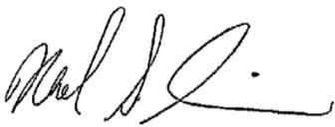

Neal S. Simon

Ex-President, American University of Antigua College of Arts and Sciences

AMERICAN UNIVERSITY OF ANTIGUA COLLEGE OF ARTS & SCIENCES ACADEMIC CATALOG 2026
6

MESSAGE FROM THE DEAN

Like the President, I would like to take this opportunity, on behalf of the faculty, students and staff of the College, to welcome you to our community of scholars. We define scholars as those individuals who have chosen to strive to attain perfection. Whether or not you reach this goal is secondary to your efforts. At the very least, you will have become a better person, gained knowledge and skills, and provided a service to the community.

While at AUACAS, we have the following expectations of our scholars:

COMMITMENT TO EXCELLENCE RESPECT for the COMMUNITY INDEFATIGABLE DRIVE TO EXCEL HONOR and INTEGRITY

I challenge you to be all that you can, to remember the reason that you came to us and to be indefatigable in your desire to achieve your goals. In the words of Mahatma Gandhi: “Man often becomes what he believes himself to be. If I keep on saying to myself that I cannot do a certain thing, it is possible that I may end by really becoming incapable of doing it. On the contrary, if I have the belief that I can do it, I shall surely acquire the capacity to do it even if I may not have it at the beginning.”

The document that follows describes the rules and policies of the College. Please familiarize yourself with its contents. If you have any questions, do not hesitate to communicate with any of the faculty or staff.

Welcome!
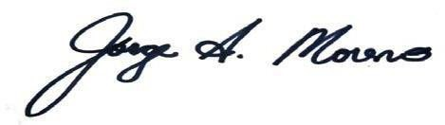
Dr. Jorge A. Moreno, Dean
American University of Antigua College of Arts and Sciences

AMERICAN UNIVERSITY OF ANTIGUA COLLEGE OF ARTS & SCIENCES ACADEMIC CATALOG 2026 7

STUDENT ACHIEVEMENT

Student achievement is posted on the auacas.org website.

TABLE OF CONTENTS

TOPIC PAGE

MISSION AND OBJECTIVES 11
BACKGROUND 12
GENERAL EDUCTION REQUIREMENT 13
EMERGENCY MEDICAL TECHNICIAN PROGRAM 16
COMMUNITY ENRICHMENT PROGRAM 16
NON-DEGREE PROGRAM 16
COURSE DESCRIPTIONS 18
ADMISSIONS 28
GRADUATION REQUIREMENTS 32
RESIDENTIAL SERVICES 33
COLLEGE REGISTRATION 34
TUITION AND FEES 35
REFUND POLICY/ LATE PAYMENTS/ FINANCIAL AID/ SCHOLARSHIPS/GRANTS
ACADEMIC DEFINITIONS 38
GRADE POINT AVERAGE CALCULATION 38
ATTENDANCE 39
ACADEMIC POLICIES 40
ACADEMIC EXPECTATIONS 40
ACADEMIC STANDARDS AND SAP 41
TABLE OF CONTENTS
TOPIC PAGE
EVALUATION OF ACADEMIC PERFORMANCE 44
ACADEMIC PROBATION 44
RETURNING TO SATISFACTORY ACADEMIC PROGRESS 45
GOOD STANDING and GOOD STANDING
FOR FINANCIAL AID ELIGIBILITY 45
TESTING ACCOMMODATIONS 45
ABSENCES AND LEAVES 47
GRIEVANCES AND DISCIPLINARY ACTION 49
APPEALS PROCEDURES 50
PROFESSIONAL CONDUCT AND ETHICAL BEHAVIOR 51
STUDENT HOUSING 51
CAMPUS TRANSPORTATION 52
CAMPUS PARKING GUIDELINES 52
STUDENT GOVERNMENT ASSOCIATION 54
SPORTS ACTIVITIES 54
HOLIDAYS 54
POLICY OF NON-DISCRIMINATION 54
PRIVACY RIGHTS 56
INFORMATION TO BE DISCLOSED 57

MISSION AND OBJECTIVES
MISSION STATEMENT

The mission of the American University of Antigua College of Arts and Sciences is to educate and nurture students in vocational and pre-vocational studies, to promote student and faculty development, and to provide the resources needed to produce articulate, ethical, and critically thinking citizens.

The College is committed to serving the worldwide community with an emphasis on the Americas and the Caribbean. It offers access to post-secondary education for those who can benefit without regard to religious belief, race, age, gender, marital status, or national origin.

MISSION OBJECTIVES

The mission objectives of the American University of Antigua College of Arts and Sciences are as follows:

1. To educate students in successful programs leading to a vocation in health sciences,
2. To provide quality didactic and experiential education that prepares graduates to perform competently in medical school, and to increase their awareness of the need to obtain basic knowledge to begin a vocation in the medical field.
3. To continuously enhance the institution’s educational process and offerings to impart essential skills, competencies, and attributes needed by students for success after graduation.

The vision of the American University of Antigua College of Arts and Sciences is to create a community that promotes life-long learning, academic excellence, intellectual curiosity, and community service.

CORE VALUES

The core values of the American University of Antigua College of Arts and Sciences are as follows:

We value the diversity of our community.
We respect the beliefs of all in our community.
We are committed to freedom of inquiry.
We are committed to excellence in teaching and research.
We are committed to providing students with the foundations required of ethical citizens.
We are committed to service to the community.

BACKGROUND
ABOUT THE AMERICAN UNIVERSITY OF ANTIGUA COLLEGE OF ARTS and SCIENCES (AUACAS)

The American University of Antigua College of Arts and Sciences is organized as a corporation under the laws of Antigua and Barbuda with the following officers: President, and Secretary.

The American University of Antigua College of Arts and Sciences offers programs that culminate in the awarding of post-secondary degrees and provide educational opportunities to the community.

Credit courses are offered in programs leading to the Associate of Science (A.S.) in Health Sciences.

The A.S. in Health Sciences program prepares students to pursue further study at four- year institutions, or to seek professional degrees at the Colleges and Schools of the American University of Antigua, and elsewhere.

Students may also take credit and non-credit courses in the Community Enrichment Program and Non-Degree Programs.

DEGREE PROGRAM:

ASSOCIATE OF SCIENCE IN HEALTH SCIENCES

Health Sciences is provided for those students who wish to pursue advanced study in medicine. However, this program may also be used to pursue careers in other health science related fields such as veterinary science, dentistry, physician assistant, and health technician, among others. The course offerings allow students to complete part of their curriculum in Antigua before transferring to another institution. Students wishing to pursue medicine (M.D.) may apply directly to the American University of Antigua’s College of Medicine.

In addition to the specific course requirements, a student must satisfy a general education
requirement in Humanities, Science and Mathematics, and Social Sciences.

GENERAL EDUCATION REQUIREMENT

The College requires students to complete courses in general education. This requirement provides students with broader academic experience than would be provided by taking only the core subjects required by the major. The general education requirement consists of eighteen (18) credits in the following subject areas. The courses satisfying these areas are:
Humanities: English and Composition I and II
Mathematics and Sciences: Pre-Calculus with College Algebra, Physics for Life Sciences
Social Sciences: Economics, Learning Strategies

Learning Outcomes

Successful graduates are individuals who demonstrate competency in each of the following areas:
Area 1: Comprehension of key basic principles relating to prerequisite and core courses - Biology, Chemistry, Mathematics, Health Sciences, Anatomy and Physiology, Psychology
Area 2: Effective communication skills, both oral and written.
Area 3: Skills in laboratory techniques.
Demonstration of competency in each area is measured by:
Area 1: Successful completion of each course.
Area 2: Successful completion of English and Composition I and II, and evaluation of oral presentations in these and other courses (e.g., Introduction to Economics).
Area 3: Successful completion of 210 hours of laboratory experience in seven courses.

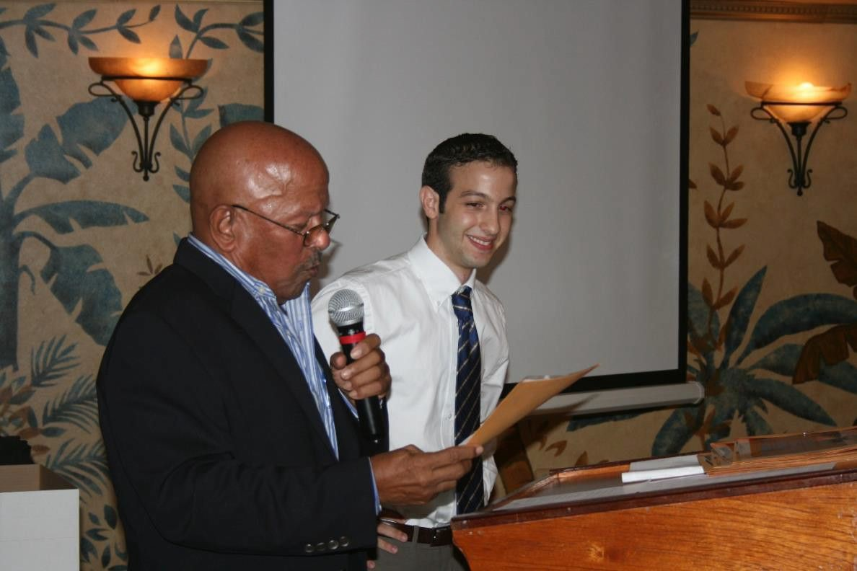

Students must fulfill all the following requirements to earn the Associate of Science in Health Sciences. This curriculum includes the minimum 18 credits of general education courses in Humanities, Mathematics and Science, and Social Sciences (designated with *).

Semester 1
CHEM 110 (or CHEM110L and CHEM 110R) |  | General Chemistry I | 4 CR
ENG 100 |  | *English and Composition I | 3 CR
BIO 110 (or BIO 110L and 110R) |  | Introductory Biology I | 4 CR
MATH 109 |  | *Pre-Calculus with College Algebra | 4 CR
EED 100 |  | *Learning Strategies | 1 CR
Semester 2
CHEM 111(or CHEM111L and CHEM 111R) |  | General Chemistry II | 4 CR
ENG 101 |  | *English and Composition II | 3 CR
BIO 111 (or BIO 111L and 111R) |  | Introductory Biology II | 4 CR
MATH 112 |  | Introduction to Statistics | 4 CR
HSC 100 |  | Introduction to Health Sciences | 1 CR
Semester 3
CHEM 209 (or CHEM 210L and CHEM 210R) |  | Organic Chemistry for Life Sciences | 4 CR
PHY 109 (or PHY 110L and PHY 110R) |  | Physics for Life Sciences | 4 CR
BIO 210 |  | Cell Biology | 3 CR
PSY 100 |  | Psychology | 3 CR
Bio 219 |  | Medical Terminology | 1 CR
Semester 4
CHEM 212 |  | Biochemistry | 3 CR
BIO 220 |  | Human Anatomy and Physiology | 5 CR
ECON 100 |  | *Introduction to Economics | 3 CR
BIO 212 |  | Microbiology and Genetics | 4 CR

NOTE: MATH 111 (Calculus) may substitute for MATH 112.

All students who matriculate into the A.S. in Health Sciences Program are automatically enrolled in the Fast Track to Medical School option. This option allows a student to apply to the American University of Antigua College of Medicine after completing the AS degree program, attaining a minimum cumulative GPA, and meeting other requirements set by the medical school. If a student does not wish to fast-track to medical school, they may choose not to pursue that option and may apply to other schools for further education. Please contact Dr. Jorge A. Moreno (jmoreno@auacas.net) for additional details.

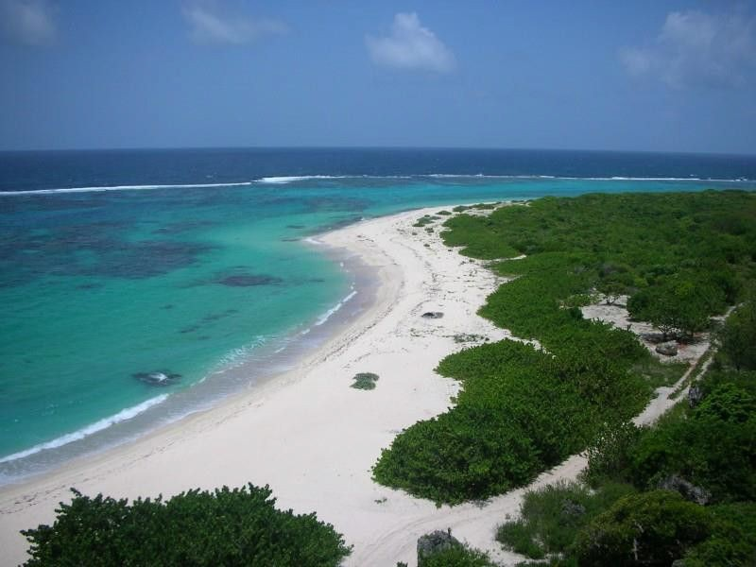

OTHER PROGRAMS

COMMUNITY ENRICHMENT PROGRAM

The Community Enrichment Program is designed to provide educational resources to the greater Antigua and Barbuda community, and beyond. The program offers noncredit courses to traditional and nontraditional students, professionals requiring continuing education credit, and those seeking life-enrichment courses, among others. Individuals who wish to participate in this program must fill out an application. The application may be obtained from the administrative staff at the AUACAS campus or requested electronically from ymorris@auacas.net. Acceptance is based on space availability. Fees are assessed and vary per course. Courses are not necessarily offered each semester. Course offerings will be advertised locally.

NON-DEGREE PROGRAM

The Non-Degree Program offers college courses for credit to students who do not want to earn a degree but may want to transfer coursework to another institution. It is the responsibility of those students who wish to transfer credit to contact the intended recipient school for credit acceptance. Two options exist: Non-Degree Program/AUA for students wishing to transfer credits to AUA, and the Non-Degree Program/Other for students wishing to transfer credits elsewhere.

Please contact an admissions representative for additional information: American University of Antigua College of Arts and Sciences Please contact an admissions representative for additional information: Contact American University of Antigua College of Arts and Sciences using the following toll-free number: 1-(888) 282-8633.

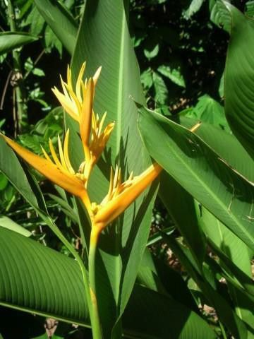

COURSE DESCRIPTIONS

Numbering System:

Prefix: Subject Designation (e.g., BIO, CHEM, etc.)
Numbers: Courses designated as 100-level are intended for first academic year students. The first course in any 100-level sequence typically does not require a pre-requisite. Courses designated as 200-lvel and beyond are intended for second year academic students.
L=lecture only, R=lab only

BIOLOGICAL SCIENCES (BIO)
BIO 110 INTRODUCTORY BIOLOGY I
4 credits
This course begins our exploration of the basic principles of biology. The first semester introduces the student to the scientific method, chemical and physical science basics for biologists, cell structure, biochemical pathways and finishes with a rigorous survey of genetics. (3 hr. lecture, 3 hr. lab)

BIO 110L INTRODUCTORY BIOLOGY I LECTURE
3 credits
The lecture portion of BIO 110, intended primarily for students who have been granted transfer credit for the laboratory.

BIO 110R INTRODUCTORY BIOLOGY I LAB
1 credit
The laboratory portion of BIO 110, intended primarily for students who have been granted transfer credit for the lecture portion.

BIO 111 INTRODUCTORY BIOLOGY II
4 credits
This course continues our exploration of the basic principles of biology. The second semester covers evolution, plant structure and function, animal structure and function, and ecology. (3 hr. lecture, 3 hr. lab) Pre-requisite: Introductory Biology I, or permission of the instructor.

BIO 111L INTRODUCTORY BIOLOGY II LECTURE
3 credits
The lecture portion of BIO 111, intended primarily for students who have been granted transfer credit for the laboratory.

BIO 111R INTRODUCTORY BIOLOGY II LAB
1 credit
The laboratory portion of BIO 111, intended primarily for students who have been granted transfer credit for the lecture portion.

BIO 210 CELL BIOLOGY
- credits
This course will introduce the student to the molecular and biochemical bases for cell structure and function. Topics that are covered include cell types, membrane organization, solute translocation, endocytosis and exocytosis, the mechanisms of signal transduction, organellar structure and function, replication, transcription and translation, certain biochemical pathways, growth control and oncogenesis. Examples used will include descriptions of medical conditions induced by cellular malfunctioning. (4 hr. lecture) Pre-requisite: Introductory Biology II or equivalent, or permission of the instructor.

BIO 211 GENETICS
- credits
This course provides a comprehensive introduction to the sciences of genetics. Topics to be covered include basic Mendelian genetics, probability, extensions to Mendelian genetics, pedigree analysis, molecular genetics [structure of nucleic acids and proteins, the central dogma, replication, transcription and translation], the genetics of bacteria and viruses, the control of gene expression, the genetics of development, population genetics and quantitative genetics. (4 hr. lecture) Pre-requisite: Introductory Biology II or equivalent, or permission of the instructor.

BIO 212 GENETICS AND MICROBIOLOGY
4 credits
This combined course provides a comprehensive introduction to the sciences of genetics and microbiology. Topics to be covered in the genetics portion include basic Mendelian genetics, probability, extensions to Mendelian genetics, pedigree analysis, molecular genetics [structure of nucleic acids and proteins, the central dogma, replication, transcription and translation], the genetics of bacteria and viruses, the control of gene expression, the genetics of development, population genetics and quantitative genetics.
The microbiology portion is an in-depth study of the distinguishing characteristics of microorganisms based on structural-functional relationships, taxonomy, growth, and physical-chemical agents of control including antibiotics, metabolism, and genetics. Introduces applied microbiology emphasizing infectious diseases, microbial physiology, basic concepts of immunology, mechanisms of resistance, and microbial ecology. (4 hr. lecture) Pre-requisite: Introductory Biology II or equivalent, or permission of instructor.

BIO 213 MICROBIOLOGY
4 credits
This course is an in-depth study of the distinguishing characteristics of microorganisms based on structural- functional relationships, taxonomy, growth, and physical-chemical agents of control including antibiotics, metabolism, and genetics. Introduces applied microbiology emphasizing infectious diseases, microbial physiology, basic concepts of immunology, mechanisms of resistance, and microbial ecology. (4 hr. lecture) Pre- requisite: Introductory Biology II or equivalent, or permission of instructor.

BIO 219 MEDICAL TERMINOLOGY
1 credit
This course guides the student in understanding the principles of medical word building (word roots, prefixes, suffixes and combining vowel/form). This in turn enables the student to obtain a good grasp of the extensive medical vocabulary used in health care occupations. Using a systemic approach as a platform, this course provides the students with the opportunity to define, interpret, and pronounce medical terms relating to structure (anatomy) and function (physiology), pathology, diagnosis, clinical procedures, oncology, and pharmacology. In addition to medical terms, common abbreviations applicable to each system will be interpreted. (1 hr. lecture) Pre-requisite: Introductory Biology II or equivalent, or permission of instructor.
BIO 220 HUMAN ANATOMY AND PHYSIOLOGY
5 credits
A one-semester course offering a survey of human anatomy and physiology at the cellular, tissue, and organ system levels of organization. Topics to be discussed include anatomical terminology, aspects of physiological function, and the integumentary, digestive, excretory, circulatory, respiratory, skeletal, muscular, nervous, sensory, and endocrine systems. Dissection of human cadavers is required. (4 hr. lecture, 3 hr. lab) Pre-requisite: Introductory Biology II or equivalent, or permission of instructor.

CHEMISTRY (CHEM)

CHEM 101 INTRODUCTION TO CHEMISTRY
4 credits
This course will expose the student to the basic chemistry concepts necessary for later success in general chemistry. An emphasis on math skills and algebraic relationships will provide students with a background for further studies in chemistry. This course cannot be used to fulfill requirements of associate degree programs in health sciences and EMT-paramedic. (3 hr. lecture, 3 hr. lab)

CHEM 110 GENERAL CHEMISTRY I
4 credits
This course begins the exploration of the basic principles of general chemistry. It covers atomic structure, the periodic table, ionic and covalent bonding, the mole concept and gas laws. It also briefly looks at transition metals and their importance in biochemical molecules. (3 hr. lecture, 3 hr. lab)

CHEM 110L GENERAL CHEMISTRY I LECTURE
3 credits
The lecture portion of CHEM 110, intended primarily for students who have been granted transfer credit for the laboratory.

CHEM 110R GENERAL CHEMISTRY I LAB
1 credit
The laboratory portion of CHEM 110, intended primarily for students who have been granted transfer credit for the lecture portion.

CHEM 111 GENERAL CHEMISTRY II
4 credits
This course continues the exploration of general chemistry with analytical methods including titration and some aspects of chromatography, equilibria and buffers, entropy and Gibbs free energy, chemical kinetics, thermodynamics and the shapes of molecules. (3 hr. lecture, 3 hr. lab) Pre-requisite: General Chemistry I or equivalent, or permission of the instructor.

CHEM 111L GENERAL CHEMISTRY II LECTURE
3 credits
The lecture portion of CHEM 111, intended primarily for students who have been granted transfer credit for the laboratory.

CHEM 111R GENERAL CHEMISTRY II LAB
1 credit
The laboratory portion of CHEM 111, intended primarily for students who have been granted transfer credit for the lecture portion.

CHEM 209 ORGANIC CHEMISTRY FOR LIFE SCIENCES
4 credits
This course covers the basic and fundamental principles of organic chemistry and exposes students
to the concepts of chemical bonding in organic molecules, functional groups, nomenclature,
stereochemistry and reaction mechanisms (3 hr. lecture, 3 hr. lab) Pre-requisite: General Chemistry II, or equivalent.

CHEM 210 ORGANIC CHEMISTRY I
4 credits
This course begins the exploration of organic chemistry. Topics covered include nomenclature, structure and reactions of alkanes, alkenes, alkynes, alkyl halides, and aromatics, stereochemistry and mechanisms and dynamics of organic reactions. (3 hr. lecture, 3 hr. lab) Pre-requisite: General Chemistry II, or permission of instructor.

CHEM 210L ORGANIC CHEMISTRY I LECTURE
3 credits
The lecture portion of CHEM 210, intended primarily for students who have been granted transfer credit for the laboratory.

CHEM 210R ORGANIC CHEMISTRY I LAB
1 credit
The laboratory portion of CHEM 210, intended primarily for students who have been granted transfer credit for the lecture portion.

CHEM 211 ORGANIC CHEMISTRY II
4 credits
This course continues the exploration of organic chemistry. Topics covered include nomenclature, structure and reactions of alcohols, ethers, carboxylic acids, aldehydes, ketones, heterocycles, carbohydrates, lipids, nucleic acids and proteins. Synthesis and reaction techniques are emphasized. (3 hr. lecture, 3 hr. lab) Pre- requisite: Organic Chemistry I, or permission of instructor.

CHEM 211L ORGANIC CHEMISTRY II LECTURE
3 credits
The lecture portion of CHEM 211, intended primarily for students who have been granted transfer credit for the laboratory.

CHEM 211R ORGANIC CHEMISTRY II LAB
1 credit
The laboratory portion of CHEM 211, intended primarily for students who have been granted transfer credit for the lecture portion.

CHEM 212 BIOCHEMISTRY
3 credits
This course serves as a basic introduction to the principles of biochemistry (3 hr. lecture). Pre-requisite: General Chemistry II, or permission of the instructor. An introductory organic chemistry course is recommended but not required.

ECONOMICS (ECON) ECON 100 ECONOMICS
3 credits
An introduction to basic principles of micro- and macro- economics, especially as how they relate to the health sciences. (3 hr. lecture) No pre-requisites.

EDUCATIONAL ENHANCEMENT DEPARTMENT (EED)

EED 100 LEARNING STRATEGIES
1 credit
This course is designed to help first-semester students become engaged members of the AUACAS academic community. The course encourages students to claim their education through a focus on the process of learning how to learn and cultivating the habits of mind for lifelong achievement and success. Rooted in college student development theory, the course is an inquiry into the academic expectations, resources, policies, and traditions of university life at AUACAS. Students are challenged to enhance their intellectual potential, understand their academic and moral responsibilities, and appreciate diversity in a framework that develops the critical thinking, learning, and communication skills necessary to contribute successfully to the university. This is a required course for all incoming first-semester students in any of the degree-granting programs. (1 hour lecture for 6 weeks)



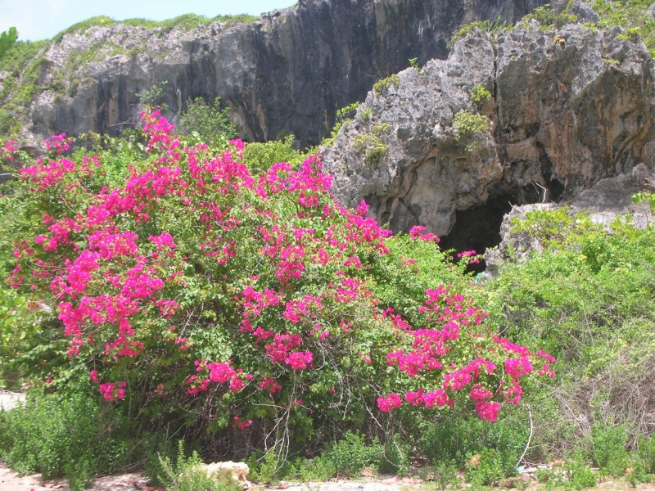
COURSE DESCRIPTIONS

ENGLISH AND LITERATURE (ENG)

ENG 099 ENGLISH FOR ACADEMIC PURPOSES
3 credits
This course is designed for students who need a semester of preparatory English language instruction. Students are enrolled in this course after an evaluation by the English language instructors of the College. The course consists of lectures and individual teacher-student meetings. (3 hr. lecture)

ENG 100 ENGLISH AND COMPOSITION I
3 credits
This course fosters the development of fluent, effective, and confident writers. It expands a student’s ability and versatility in reading, language awareness, and composing for a range of purposes, audiences, and situations, including academic research writing. The course consists of lectures and individual teacher- student meetings. (3 hr. lecture)

ENG 101 ENGLISH AND COMPOSITION II
3 credits
This course continues the development of fluent, effective, and confident writers. The course consists of lectures and individual teacher-student meetings. (3 hr. lecture)

HEALTH SCIENCE (HSC)

HSC 100 INTRODUCTION TO HEALTH SCIENCES
1 credit
This course serves as an introduction to topics in the health sciences, including determinants of health,
heath care systems, ethics, and legal issues, among others. (1 hr. lecture).
INTERDISCIPLINARY STUDIES (RES)

RES 501 RES 502 RES 503 RES 504
INDEPENDENT STUDY OR RESEARCH INDEPENDENT STUDY OR RESEARCH INDEPENDENT STUDY OR RESEARCH INDEPENDENT STUDY OR RESEARCH

- credit
- credits

- credits

- credits

This course provides the student with an in-depth exploration of a particular topic of interest under the supervision of a faculty mentor. It offers an opportunity to pursue a subject that interests the student, but which may not be adequately covered in a typical course. It is expected that the student will develop critical thinking skills, gain experience in scientific methodology, learn more about a particular subject, and appreciate the relevance of research to the appropriate field.

MATHEMATICS (MATH)

MATH 103 COLLEGE ALGEBRA
3 credits
This course will introduce the student to essential concepts of algebra. Topics to be covered include conversion of measurements within and between various systems of weights and measures, real numbers and their properties, solving equations and inequalities, exponents and polynomials, factoring, rational expressions, graphing linear equations, solving systems of linear equations, roots and radicals, and mathematical reasoning skills. This course cannot be used to fulfill the requirements of associate degree programs in nursing and health sciences. (4 hr. lecture)

MATH 109 PRE-CALCULUS WITH COLLEGE ALGEBRA
4 credits
This course combines topics covered in MATH 103 and 109, which are key to tackling upper-level science classes.
(4 hr. lecture) Pre-requisite: High School mathematics or equivalent.

MATH 110 PRE-CALCULUS
4 credits
This course develops techniques and concepts prerequisite to calculus through the study of trigonometric, exponential, logarithmic, polynomial, and other functions and their applications. This course is intended for students with one year of high-school algebra, but the requirement may be waived by the instructor. (4 hr. lecture

MATH 111 CALCULUS
4 credits
This course serves as an introduction to the fundamental concepts of calculus and their applications. It covers limits, derivatives of algebraic and trigonometric functions, applications of the derivative, integration and application of the definite integral. (4 hr. lecture) Pre-requisite: Pre-Calculus or equivalent.

MATH 112 INTRODUCTION TO STATISTICS
4 credits
An introductory statistics course that introduces the principles and methods of collecting, analyzing, and interpreting data.
It covers descriptive statistics, probability, and the foundations of statistical inference, including hypothesis testing,
confidence intervals, and regression. (4 hr. lecture) Pre-requisite: Any algebra or related course.

PHYSICS (PHY)

PHY 109 PHYSICS FOR LIFE SCIENCES
4 credits
This is a one-semester algebra-based physics course. This course introduces the fundamental principles of classical
mechanics, fluids, thermodynamics, waves, sound, and optics. Applications relevant to the life sciences and the medical
profession will be emphasized. (3 hr. lectures, 3 hr. lab)

PHY 110 INTRODUCTORY PHYSICS I
4 credits
This course begins the exploration of the basic principles of algebra-based physics. The course covers classical mechanics, fluids, and waves. (3 hr. lecture, 3 hr. lab).

PHY 110L INTRODUCTORY PHYSICS I LECTURE
3 credits
The lecture portion of PHY 110 is intended primarily for students who have been granted transfer credit for the laboratory.

PHY 110R INTRODUCTORY PHYSICS I LAB
1 credit
The laboratory portion of PHY 110 is intended primarily for students who have been granted transfer credit for the lecture portion.

PHY 111 INTRODUCTORY PHYSICS II
4 credits
This course continues the exploration of the basic principles of algebra-based physics. The course covers basics of electrical physics, power, electromagnetism, optics, quantum theory, heat, radioactivity and nuclear physics. (3 hr. lecture, 3 hr. lab). Pre-requisite: Physics I or equivalent, or permission of instructor.

PHY 111L INTRODUCTORY PHYSICS II LECTURE
3 credits
The lecture portion of PHY 111 is intended primarily for students who have been granted transfer credit for the laboratory.
PHY 111R INTRODUCTORY PHYSICS II LAB
1 credit
The laboratory portion of PHY 111 is intended primarily for students who have been granted transfer credit for the lecture portion.

PSYCHOLOGY (PSY)
PSY 100 PSYCHOLOGY
- credits
This course serves as an introduction to the science of psychology. The course was designed to permit analysis of experimental and applied psychology, in addition to surveying the entire field.
(3 hr. lecture).

SPANISH (SPAN)
[These courses do not have pre-requisites]

SPAN 100 INTRODUCTION TO SPANISH FOR HEALTH CARE WORKERS
- credits
An introductory Spanish course designed for those individuals who wish to do clinical rotations, internships, or to practice in areas with a significant Spanish-speaking population. No previous knowledge of Spanish is required. (4 hr. lecture)

SPAN 101 BASIC SPANISH
4 credits
A basic course designed to understand, speak, read, and write Spanish. It offers a balanced approach to language and culture. Basic communicative functions and structures are introduced. (4 hr lecture).



GENERAL ADMISSIONS CRITERIA

ADMISSIONS

- The following people are eligible for admission to the degree or certificate-granting programs of the College (all students must provide the College with an official high school transcript or equivalent)
  - Graduates from accredited high schools in the United States;
  - Transfer students from accredited post-secondary institutions in the United States;
  - Graduates from foreign academic institutions equivalent to U.S. secondary school education and who meet language standards established by the College (see page 29);
  - Transfer students from foreign academic institutions equivalent to U.S. post- secondary school education and who meet language standards established by the College (see page 29).

- For students from foreign-language institutions, evidence of completion of their education must be submitted with an official English translation.

- Students wishing to take courses in the Community Enrichment Program must complete the appropriate application and submit it to the administration office of AUACAS (AUACAS, University Park, Coolidge, St. John’s, Antigua). Fees are assessed. Information on fees may be obtained at the Antigua office.

- Students wishing to take courses in the Non-Degree Program/AUA or Other must apply following the same procedures as required of A.S. in Health Sciences degree- seeking students, except that evidence of high school completion is not required if candidates have earned at least 90 credits of undergraduate education, or bachelor’s or more advanced degrees. Fees are assessed and are listed in the Fee Schedule.

- VISA REQUIREMENTS: All applicants must check for any visa restrictions that may apply vis-à-vis their country of citizenship. Information on visa requirements can be obtained from the webpage of the Government of Antigua and Barbuda (www.ab.gov.ag).

ASSOCIATE OF SCIENCE IN HEALTH SCIENCES

All qualified applicants will have earned a high school diploma or equivalent (e.g. GDE), with a GPA of at least 2.8, and at least 1000 or 22 on the SAT or ACT, respectively. Students who have taken college courses may use this completion to substitute for lower-than-expected high school GPA or SAT/ACT scores, if the admissions committee deems the student is qualified to handle the College’s workload. English, Mathematics, Biology, and Chemistry courses are required. Physics is not required, but is encouraged.

All applicants from Caribbean Community (CARICOM) countries will have earned a high school diploma, fifth-form diploma, or its equivalent, with a GPA of at least 2.8. The applicant must also have CSEC (previous CXC) scores in the following subjects: English, Mathematics, Chemistry, and Biology, with a score of 1 or 2 (a score of 3 is allowed for one subject). A Physics score is not required but is encouraged. SAT and ACT scores from students from CARICOM and other foreign graduates are not required but encouraged.

Each applicant, however, will be evaluated on his/her individual merits, and an applicant may occasionally be admitted with a lower than desired GPA or standardized exam score if the Admissions Committee feels that enrollment will benefit the applicant and enhance the College community. Some such applicants would have completed college work but are not offered transfer credit.

Transcripts of applicants from non-US/Canadian/Antiguan schools must be submitted with an evaluation from a service approved by the National Association of Credential Evaluation Services (NACES).

SUPPLEMENTAL ADMISSIONS REQUIREMENTS
AUACAS’s curriculum is taught in English, and all accepted students must be proficient in English. If English is not your primary language, AUACAS requires that you confirm your mastery of English by taking the Test of English as a Foreign Language (TOEFL), or the International English Language Test System (IELTS).

Who needs to take the TOEFL or IELTS?
- All applicants who graduated from institutions located in countries where English is not the primary language; and/or
- All applicants whose primary language is not English; and/or
- As requested by the AUACAS Admissions Committee if it appears that language could interfere with the student’s academic success at AUACAS.
- What is the current cutoff score for these exams?
The current overall cutoff score for the TOEFL is 90 (Internet-based total, or its equivalent on the computer-based or paper-based versions); and
- The current overall cutoff score for the IELTS is 7 (overall bandscore).

HOW TO APPLY
GENERAL PROCEDURES FOR CANDIDATES APPLYING TO THE DEGREE AND NON-DEGREE PROGRAMS

- The following documentation is required before the application is considered complete and ready for review by the Admissions Committee.
  - Official transcripts from all schools attended.
  - Two official letters of recommendation, one of which must be from an academic source. The letters of recommendation (both academic and non- academic) must be signed and on stationery with the official letterhead, and with contact information (postal address, email, and/or phone). Letters of recommendation that are on stationery with an official letterhead and are attached to an email but are not signed must carry the following statement instead of a signature: “This letter of recommendation was sent electronically and does not bear my signature. I may be contacted by …” The letters of recommendation must not be written by a first or second-degree relative. Academic letters of recommendation must be from a college professor (faculty member) or a high school teacher whose course(s) the applicant has attended. Academic letters of recommendation from lab technicians, graduate students, school counselors, etc., are not acceptable. Academic letters of recommendation are not required of students who have been out of school for two or more years, but are encouraged.
  - A Personal Statement explaining why you are considering a career in your chosen major, why you would be an asset to the College, significant accomplishments or activities, personal interests, and any other information that would be useful to the Admission Committee in evaluating your application. The statement must be no less than 1 page in length and no more than 2 pages.
  - One (1) passport-sized photo.
- Completed application form.
- A non-refundable $75.00 application fee in the form of a check or money order drawn on U.S. currency (payable to the American University of Antigua College of Arts and Sciences).
- The completed application for admissions and supporting documentation should be sent to the following address: American University of Antigua College of Arts and Sciences, c/o Manipal Education Americas, LLC, 115 Broadway, 5th Floor, New York, New York, 10006. Attn: Office of Admissions. You may speak to admissions representatives by calling the following toll-free number 1-(888)-282-8633.

TRANSFER CREDIT INFORMATION

AUACAS accepts college-level transfer credits from accredited institutions within the United States (as approved by the Secretary of the U.S. Department of Education), and/or from foreign institutions on a case-by-case basis. Credit transfers are evaluated by the Admissions Committee and are not guaranteed. However, credit may be granted only for courses in which grades of “C” or better have been earned. A transfer student’s transcripts become part of the official student's permanent record. The Admissions Committee examines the totality of a student's academic history and provides the student with an academic program that best guarantees success. This sometimes means the repetition of courses.

Once a student matriculates and commences a program at AUACAS, the student CANNOT take courses outside of AUACAS to complete the requirements of the program into which the student matriculated.

Students who have taken courses in non-English speaking countries must have an official certified translation made of their transcripts and submit this translation to the Office of Admissions. The certified translation must be submitted in conjunction with the official transcript as part of the completed application to the Office of Admissions.

ARTICULATION AGREEMENTS

The College has entered into articulation agreements with the following institutions to provide additional options for our graduates. Some of these institutions are:

- American University of Antigua College of Medicine
- Mercy College in New York
- Assumption College in Massachusetts
- University of Bridgeport in Connecticut
- University of the Fraser Valley in British Columbia, Canada.
- State University of New York at Plattsburg
- Monmouth University
- Dominican College (New York)
- Caldwell College (New Jersey)
- Culver-Stockton (Missouri)

Please check the College website (auacas.org) for additional articulation agreements.

GRADUATION AND COMPLETION REQUIREMENTS
ASSOCIATE OF SCIENCE IN HEALTH SCIENCES DEGREE

Students accepted into the program who complete all required coursework, obtain a minimum cumulative GPA of 2.0, and have no outstanding financial obligations to the College are granted an Associate of Science (A.S.) diploma. At least thirty (30) of the required credits for graduation must be obtained within the American University of Antigua College of Arts and Sciences. Students must be enrolled in residence at the College for at least one-half of the prescribed number of semesters required for graduation. The final term must be in residence.

EACH STUDENT IS RESPONSIBLE FOR THE COMPLETION OF ALL REQUIREMENTS FOR THE DEGREE AND SHOULD CHECK PROGRESS REGULARLY WITH THEIR ADVISOR, OR THE ASSOCIATE REGISTRAR.

OTHER PROGRAMS

Students who are admitted to the non-degree programs are considered to have completed the program if they pass all the required assigned classes. Any student who completes the Non- degree/AUA option will be considered for admission to the American University of Antigua College of Medicine by its Admission Committee. A final determination for admission is made exclusively by this committee.

RESIDENTIAL SERVICES

COUNSELING AND ADVISING SERVICES

At the beginning of each semester, every student is assigned to an Academic Advisor, who will help with scheduling and other academic matters.

Through an agreement with the American University of Antigua College of Medicine, all College students, faculty, and staff have access to the University Counseling Center (UCC). The UCC strives to create a healthier campus with a balance between prevention and counseling. For students, UCC strives to develop a place that addresses their mental health needs and aids in assuring academic success and improved retention. Overall, UCC strives to provide counseling services and psychoeducational programs that promote positive development, healthy change, wellness, and success for the entire campus communities and the community at large.

A faculty member carries a 24- hour emergency phone and can be reached at 268-764-0164. The emergency phone is reserved for issues relating to serious illness or accident, or a situation that requires the expertise of school personnel, as some examples.

REGISTRAR, BURSAR, AND RESIDENTIAL SERVICES

The College has a service agreement with the American University of Antigua and Manipal Education Americas, LLC to administer maintenance, registration, library, bursar, and housing services, among others. Please contact the Dean’s Assistant (Ms. Ann-Marie Liverpool, aliverpool@auacas.net, or (268) 484-8900, ext. 2001) for a listing of pertinent names and other contact information.

Campus Registrar: The Campus Registrar, Ms. Wendy Roberts, may be contacted via email at wroberts@auamed.net

Bursar: The Bursar, Ms. Indra Walker, may be reached at (268) 484-8900, ext. 1013, or iwalker@auamed.net.

Residential Services: The Residential Manager, Mrs. Adele Gamble may be contacted via email at acampbell@auamed.net or the Office of Residential Services for Housing information at (268) 484-8900 ext. 1021, or studentservices@auamed.net.

Transcripts: If you would like an official transcript, the cost is $10US per transcript and you would need to pay the N.Y. Bursar Department. You can get in touch with the Bursar Department by calling 212-661-8899, Option 6. The Bursar Department accepts payments of VISA or MasterCard. Once you have made the payment, please send an e-mail to one of the following depending on your last name:
A-G | Mariela Capellan | mcapellan@auamed.org
H-P | Andrew Stevens | astevens@auamed.org
Q-Z | Darwin Gonsalves | dgonsalves@auamed.org
Include in your e-mail a copy of your paid receipt that the Bursar will email you, the complete address of where the transcript needs to be sent, to whose attention, and the telephone number associated with it.

COLLEGE REGISTRATION

REGISTRATION INFORMATION
Registration takes place on the Antigua campus. For a student to be allowed to register, all relevant documents must have been submitted to and received by Residential Services and the Registrar. It is important for a student to have all identification documents and his/her acceptance letter (new students) in his/her possession at registration.
Submission of all official transcripts is a requirement for continued attendance at the College. Outstanding documents may result in the student being administratively withdrawn.

Online registration is mandatory and must be completed within the window of time established and published by college notifications. Students who have not successfully completed online registration by the established deadline will not be permitted to attend the current semester.

In addition to completing online registration, all students must report to the Registrar’s Office on campus to confirm arrival on the island and receive their student ID card and registration sticker. To confirm the reserved dates for arrival and orientation, please review the Academic Calendar located on the AUACAS website (aicasa.org).

When completing online registration, an OLR BURSAR HOLD may appear indicating tuition is not yet settled. Please contact the Bursar Department (bursar@auamed.org) if you believe your account has been settled and to request removal of the hold. Students will not be cleared to complete in-person registration confirmation until their tuition account is settled.
After completing the online registration process, students will just need to bring the confirmation clearance forms that are generated from successfully completing the online registration process, to the Registrar’s Office on island to receive their semester sticker. An identification card is distributed to each student during registration and each student is required to always carry the card while on campus. A student is also required to present his/her ID card when requested to do so by college officials. The card also allows AUACAS students to use the facilities of the American University of Antigua.
A student who is not officially registered for the semester will not be permitted to attend classes.

TUITION AND FEES
The College assesses tuition and fees. Current rates of tuition and fees are listed in Addendum A.
Tuition and fees must be paid in full at registration unless accompanied by a written exemption authorized by the Bursar. Payment of tuition and fees is due 10 days before registration. The entire balance, including housing, transportation, and health insurance, must be paid, or Financial Aid must be approved to register for classes. If you are not applying for Financial Aid, but paying directly, payment can be made by:

- Wire transfer (see wire instructions below)
- Certified check or bank draft
- Money Order
- ACH/Electronic Check – Enter ID at http://www.ecsi.net/gateway/auamed.html

Certified check, bank draft, or money order should include your AUACAS ID in the memo field and can be mailed to:
Manipal Education Americas, LLC Representative for
American University of Antigua College of Arts and Sciences
115 Broadway, 5th Floor, New York, NY. 10006.

Wire Transfer Instructions
Beneficiary: American University of Antigua College of Arts and Sciences (AUACAS)
Bank: Citibank NY, 201 West 34th St. NYC, NY 10001
Beneficiary Account No.: 6863920221
Beneficiary ABA No.: 021000089
Beneficiary Swift Code: CITIUS33 (for wires originating outside US)
*please include your ID so that we can identify your wire REFUND POLICY
All refunds will be made within thirty (30) days of the withdrawal date. Before any refund can
be initiated, a withdrawal form must be completed and submitted to the Associate Registrar in Antigua. Tuition will be refunded according to the following schedule**:
- Prior to the first day of class, 100% of tuition and all applicable fees will be refunded.
- If any student withdraws during the first 60% of the semester, the refund will be prorated based on the withdrawal date. Only base tuition will be prorated; all other applicable fees are non-refundable.
- If any student withdraws after 60% of the semester, there are no refunds.
**The semester seat deposit of $500 US is excluded from this refund.
Short-term Leaves of Absence (LOA) have no effect on a student’s tuition account, and the student will be responsible
for the unpaid balance. Refund policy mentioned above applies to withdrawals and long-term leaves of absence.
However, no cash refunds will be made for long-term LOAs, but pro-rated credit (for approved LOAs within the first
59% of the semester) will be posted to the student’s tuition account, which will go towards reducing the next semester’s balance owed to AUACAS.

FINANCIAL AID

For detailed information regarding available loan programs, please contact the Financial Aid Department at 1-877-666-9485. The Director of Financial Aid can be reached at extension 156. Financial Aid Counselors can be reached at extensions 153 and 154, and the Financial Aid Administrative Assistant at extension 157. The department fax number is 646-417-6220.

TUITION GRANTS
Grants are available to qualified students. The following is a list of the grants currently available. All monetary amounts are in United States dollars. Grants can be extended for up to six semesters for students who do not complete their program in the expected four semesters.

GRANT FOR SOUTH ASIAN CITIZENS AND RESIDENTS
Award Amount: $10,000, awarded $2,500 per semester (1-4) at AUACAS.
Eligibility Requirements
Applicants must submit a completed application and:
- Applicants must be citizens and residents of any of the South Asian Countries (Afghanistan, Bangladesh, Bhutan, India, the Maldives, Nepal, Pakistan, and Sri Lanka)
- Proof of residency (no older than two months from the application date)
- A copy of their passport
INTERNATIONAL GRANT
Award Amount: $10,000, awarded $2,500 per semester (1-4) at AICASA.
Eligibility Requirements
Applicants must submit a completed application along with:
- Resident of a country that is not the United States or a South Asian country (Afghanistan, Bangladesh, Bhutan, India, the Maldives, Nepal, Pakistan and Sri Lanka)
- Proof of residency (no older than two months from the application date)
- A copy of their passport
ANTIGUAN TUITION GRANT
Award Amount: Full tuition and institutional fees for the entire program leading to the AS in Health Sciences degree; does not cover room, board, transportation, insurance, and other living expenses This amounts to $23,000USD for a four-semester sequence.
Eligibility Requirements:
- Must show proof of Antiguan citizenship
- Must maintain a Pass grade each period enrolled at AUACAS
- Contact the Prime Minister’s office and/or the Ministry of Education for this grant
MONTSERRAT TUITION GRANT
Award Amount: Full tuition and institutional fees for the entire program leading to the AS in Health Sciences degree; does not cover room, board, transportation, insurance, and other living expenses. his amounts to $23,000USD for a four-semester sequence.
Eligibility Requirements:
- Must show proof of Montserrat citizenship
- Must maintain a Pass grade each period enrolled at AUACAS
SIBLING OR SPOUSE ALLOWANCE
Award Amount: 20% tuition discount on the lowest tuition of one sibling or spouse; or 10% for each sibling or spouse when tuition is the same.
Eligibility Requirements:
- For siblings: a copy of your birth certificates or other legal documentation showing you have the same parent.
- For spouses: a copy of your marriage certificate, legal civil union, or registered domestic partnership at the time of the qualifying partner’s acceptance to AUACAS; couples who are legally joined after matriculation are not eligible
- Siblings or spouses may be enrolled separately in AUACOM and AUACAS to qualify for the discount
- Both students must maintain a Pass grade each period enrolled at AUACAS.
Before you apply for a grant, please review the following:
- Prior to consideration, all candidates need to be accepted to AUACAS and must submit a completed grant application and supporting documents where appropriate.
- Students who complete AUACAS and are accepted to American University of Antigua College of Medicine are eligible
- for continued grant funding. For details, visit AUACAS’s website: auacas.org).
- Grants may not exceed tuition and do not include room, board, transportation, or educational supplies unless otherwise noted.
- Grants cannot be combined.

CONTACT
Joshua James, Director of Admissions
Manipal Educations America, LLC; representatives for AUACAS
115 Broadway, 5th Floor, New York, NY 10006 jjames@auamed.org, 212-661-8899, ext 247

ACADEMIC DEFINITIONS
- Semester Credit Hour (Lecture): Defined as fifteen (15) contact hours per semester. For example, a 3-credit lecture course requires 45 hours of contact per semester.

- Semester Credit Hour (Laboratory): Defined as thirty (30) contact hours per semester.
For example, a 2-credit laboratory course requires 60 hours of contact per semester.

- Grade Point Average (GPA): Defined as the cumulative weighted average of a student’s grades.

- Letter grades for credit courses are assigned quality points as follows:

A | 4.00 | C+ | 2.50
A- | 3.75 | C | 2.00
B+ | 3.50 | C- | 1.75
B | 3.00 | F | 0
B- | 2.75
- The following designations, to which quality points are not assigned, are also used:

AUD Audit Course INC Incomplete
W Withdrawal (assigned if a student withdraws within 48 hours after the first exam) WP Withdrawal, Passing (assigned if the student is passing the course upon withdrawal); WF Withdrawal, Failing (assigned if the student is failing the course upon withdrawal).
R Replaces an F if student successfully repeats the course. IP In-progress.

GRADE POINT AVERAGE (GPA) CALCULATION
A GPA is calculated as follows: Σ [(# credits for a course) X (quality points)] ∕ [total number of completed credits]

Example: Suppose you attempt the following during a semester:

Course | Credits | Grade | Quality Points
1 | 3 | A | 12.00
2 | 5 | B+ | 17.50
3 | 2 | C- | 3.50
4 | 3 | WP | 0.00
13 attempted credits
10 completed credits

Course | 1 | 2 | 3 | 4
Credits X Quality Points | 3 X 4.00 | 5 X 3.50 | 2 X 1.75 | Not completed, not counted
Total | 12.00 | 17.50 | 3.50 | 0 | 33 QP/10  credits
GPA |  |  |  |  | 3.30

ATTENDANCE

ATTENDANCE
A student is expected to attend all scheduled classes. However, the minimum attendance requirement is 80% of the number of lectures in the subject. Students not meeting this requirement will not be allowed to sit the final examination or submit any required final paper for evaluation. A student missing 25% or more of the required class meetings for any course and for any reason will receive a grade of incomplete and will have to repeat the course the following semester.

Recitation (tutorial) and laboratory attendance is always mandatory. Failure to attend all required tutorials and laboratories may be grounds for failing the course.

Attendance and ID cards: All students must be in possession of their identity (ID) cards. Any loss must be promptly reported to the Associate Registrar. The cards must not be mutilated, defaced, or otherwise rendered ineffective for identification. ID cards must be presented to pertinent school officials when entering the campus.

Failure to carry your ID card always has repercussions. A student lacking his/her ID will not gain entry to the campus. Also, a student lacking his/her ID is not an acceptable excuse or reason for not being able to take an exam, attend a laboratory or class.

ACADEMIC POLICIES

ACADEMIC POLICIES
SATISFACTORY ACADEMIC PROGRESS [SAP]

All degree-seeking students are expected to make satisfactory academic progress (SAP). Satisfactory academic progress is defined both in terms of the accumulation of credits toward the degree and as the maintenance of a grade point average consistent with graduation requirements (for both Fast Track and Non-Fast Track students). When academic progress has not been satisfactory, the College may require the student to limit the number of credits for which he/she registers, and to seek special academic assistance and/or counseling, which the College will provide. Persistent inability to maintain satisfactory academic progress may be grounds for dismissal. The objective of the standards is to improve the performance of students and to guide them to a satisfactory and timely completion of their degree. The standards underscore the commitment of the faculty and administration to the education of the College’s students.

GRADES

All grades mandated and implemented by the College are maintained by the Registrar. The grading system for each course will appear in the course syllabus. Transcripts of students are maintained indefinitely. The faculty is responsible for informing the students about the grading system, policies, and test schedules during the first week of each semester.

ACADEMIC EXPECTATIONS

All our programs involve a mixture of classroom activities and laboratory work. A variety of teaching styles are employed depending on the instructor. Most material is delivered via lectures lasting a minimum of 50 minutes, depending on the course.

Lectures are backed up with small-group tutorials and TA sessions where you can ask, in a relatively relaxed and small group environment, about material in lectures that you did not understand, to go through problems, and to do practice exams.

A typical weekly workload for students in the AS in Health Sciences Program semester 1-3 would be:
- Twelve hours of lectures
- 6 hours of practical laboratories
- 4 hours of tutorials/TA sessions

Semester 4 in this program requires a bit more work. For every hour spent in class you will be expected to complete at least two additional hours of self- study. Your individual study time could be spent preparing for or following up on formal study sessions; doing homework and assigned worksheets; reading; assessing data from experiments; completing lab reports; and revising for examinations.

The direction of your individual study will be guided by the formal study and laboratory sessions you attend, along with your readings and assignments. However, we expect you to demonstrate an active role in your own learning by reading widely and expanding your own knowledge, understanding and critical ability.

Self-study will foster in you the ability to identify your own learning needs and determine which areas you need to focus on to become proficient in your subject area. This is an important transferable skill and will help to prepare you for the transition to medical school and working life in general.

ACADEMIC STANDARDS and SAP

The following tables summarize the minimum cumulative GPA expectations of the College for students to maintain successful academic progress and the minimum number of credits needed to be passed for students to complete the program promptly, as indicated in the tables below for the non-fast track and fast track options:

AS in Health Sciences (Non-Fast Track Option)
Percentage of Credits Earned Toward Degree | Cumulative Credits Passed | GPA
≤25% | 15 | 1.70
26-50% | 30 | 2.00
51-75% | 46 | 2.00
>75% | 61 | 2.00

AS in Health Sciences (Fast Track Option)
Percentage of Credits Earned Toward Degree | Cumulative Credits Passed | GPA
≤25% | 15 | 1.70
26-50% | 30 | 2.30
51-75% | 46 | 2.50
>75% | 61 | 2.70

A student must complete the required coursework for the degree program in which he/she is enrolled in a maximum number of semesters, not to exceed 150% of the established program length. For example, the health sciences program is designed to be completed in four (4) semesters. Under the 150% rule, however, health sciences students can complete the program in six (6) semesters.

Under extraordinary circumstances, a student may petition the Dean for an extended time (i.e., over the maximum allowed by the 150% rule). Extraordinary circumstances include, but are not limited to, an illness or financial burden that requires the student to take a reduced course load during a particular semester, or the student being required to enroll in a reduced course load during a particular semester by academic advisors, counseling staff or the Dean. The Dean will decide after consultation with the counseling and academic staff.

TRANSFER CREDIT AND ACADEMIC PROGRESS

The grades in any course accepted towards a student’s educational program upon admission are not used to calculate satisfactory academic progress. The courses, however, will count towards attempted and completed hours. With prior College approval, credits and grades of courses taken away from the College (maximum of 1 semester and 12 credits) after the student has been enrolled for at least one semester can be used to determine SAP, both in calculating GPA and credit hours completed.

COURSE WITHDRAWALS AND ACADEMIC PROGRESS

W, WP, and WF grades are not used to calculate a student’s GPA nor the number of credit hours attempted, and therefore have no bearing on satisfactory academic progress.

INCOMPLETE GRADES AND ACADEMIC PROGRESS

A grade of incomplete (INC) is not used to calculate a student’s GPA nor the number of credit hours attempted. A student is permitted two semesters to complete the course.
If the course is not completed within two semesters, the INC will be replaced by an F.
Once a grade replaces the INC designation, the student’s GPA will be recalculated with the new grade, as well as the number of credit hours attempted, and his/her satisfactory academic progress status will be determined.

NON-PUNITIVE GRADES AND ACADEMIC PROGRESS

The institution does not use non-punitive grades, therefore non-punitive grades are not used to calculate satisfactory academic progress.

REPEATED COURSES AND ACADEMIC PROGRESS

The GPA will be calculated with the exclusion of failing (F) grades if the course(s) has (have) been successfully repeated. However, on successful completion of a failed course, the F (or Fs) will be changed to R on transcripts. A course that is repeated and passed will count both for the calculation of GPA and the number of credit hours attempted towards maintaining satisfactory academic progress.

The following stipulation holds for students repeating a failed course with a laboratory component: A student who fails a course with a laboratory component may elect not to repeat the laboratory component if: 1. The instructor agrees, 2. The student is satisfied with the previous passing grade in the lab, and 3. No new labs (wholly or in part) are introduced in the repeating semester. If any new labs are introduced, the student must complete those labs, even if the instructor allows the rest to stand. In this case, a new lab grade will be calculated for the current semester.

NON-CREDIT COURSES AND ACADEMIC PROGRESS

Non-credit courses have no bearing on academic progress unless the successful completion of these courses is a required condition for a student’s academic status. In this case, the
course must be completed to permit a student to graduate – there is no other effect on satisfactory academic progress.

CHANGE OF CURRICULUM/REQUIREMENTS
Students are evaluated based on the norms established at their time of admission, or re- admission. The College does not have an extended enrollment status.

CHANGING PROGRAMS AND ACADEMIC PROGRESS

A student who wishes to change programs must reapply to the College, as the different programs may have different admissions requirements vis-à-vis GPA, etc. If accepted to the
new program, their academic progress will be evaluated from the time of entry into the new program.

NEW ACADEMIC CREDENTIAL AND ACADEMIC PROGRESS

A student who wishes to earn an additional degree, after having earned another from the College, must reapply to the College, as the different programs may have different
admissions requirements vis-à-vis GPA, etc. If accepted to the new program, their academic progress will be evaluated from the time of entry into the new program.

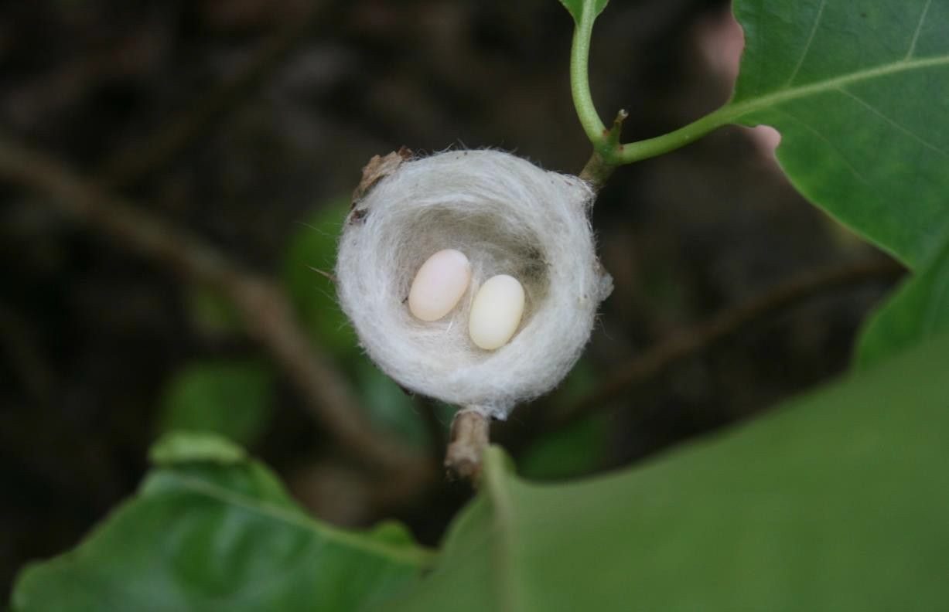

EVALUATION OF ACADEMIC PERFORMANCE

PROMOTIONS

All matters related to promotions fall under the jurisdiction of the College’s Promotions Committee. The Chair of the Promotions Committee enacts decisions made by the Promotions Committee. The Chair’s decisions may be appealed to the Appeals Committee.

At the end of each semester, a student’s satisfactory academic progress (SAP) is evaluated. The student will be notified in writing of his/her status relating to successful completion of the academic program. The following provisions apply:

  - A student who fails a course or courses in any semester is placed on Academic Probation for the following semester and must take the failed course or courses during the next semester.
  - Failing a course or courses during a semester will automatically increase the number of semesters required to complete the program.
  - A student who does not maintain the expected minimum cumulative GPA is placed on Academic Probation and may be required to undergo GPA counseling.
  - A student who does not pass the minimum required number of credits expected per evaluation period is placed on Academic Probation.
  - A student is subject to academic dismissal based upon the following:

- Failing any course while on Academic Probation.
- Failing to make Satisfactory Academic Progress.
- Repeated failures over consecutive semesters.
- A student who fails to complete the prescribed curriculum in the specified time allotment.

ACADEMIC PROBATION

The Promotions Committee of the College is responsible for placing and removing students from Academic Probation.

Any student on Academic Probation must attend seminars and workshops approved or given by the College, schedule regular meetings with his/her student advisor, and attend tutorial sessions. Students on Academic Probation are required to have a 95% attendance record for all lecture courses, and a 100% attendance record for laboratories. The academic status of each student on Academic Probation will be evaluated by the Promotions Committee at the end of each semester.

Any student placed on Academic Probation by the Promotions Committee must be aware that the probation does not automatically expire after one semester. The student will remain on

Academic Probation until the reason for the probation status has been satisfactorily removed. Students on academic probation will be notified of their status via e-mail at the end of each semester.
RETURNING TO SATISFACTORY ACADEMIC PROGRESS

A student on academic probation can return to satisfactory academic progress by earning a GPA and cumulative attempted and completed number of credits consistent with the standards outlined in Table 1, and fulfilling any other conditions imposed by the Promotions Committee. The Promotions Committee will evaluate a student on Academic Probation at the end of the probation semester to determine if the student should be removed from probation. The student is not required to submit paperwork for such a determination but is encouraged to consult with an advisor or the Dean if they have questions. The student will be notified via email of any change in academic status.

GOOD STANDING and GOOD STANDING AND FINANCIAL AID ELIGIBILITY

A student remains in good standing by complying with all academic standards, policies, and regulations established by AUACAS and by satisfying all financial obligations to the Institution or its affiliated lender. The College reserves the right to withhold services, transcripts, and certifications from a student who is not in good standing. In exceptional circumstances, determined on a case-by-case basis, the Promotions Committee reserves the right to allow a student to continue at the College while on probation, even if the student has not met all the above requirements. In such circumstances, however, the student may be ineligible for financial aid.

TESTING ACCOMMODATIONS

AUACAS recognizes the right of students with certified disabilities to appropriate test access and accommodations.

PURPOSE OF TESTING ACCOMMODATIONS

The purpose of testing accommodations is to enable students with disabilities to participate in assessment programs on an equal basis with their non-disabled peers. Testing accommodations provide an opportunity for students with disabilities to demonstrate mastery of skills and attainment of knowledge without being limited or unfairly restricted due to the effects of the disability. Testing accommodations promote the access of students with disabilities to assessment programs. Testing accommodations should not be excessive and should alter the standard administration of the test to the least extent possible.

Testing accommodations are neither intended nor permitted to:
- Alter the construct of the test being measured or invalidate the results;
- Provide an unfair advantage for students with disabilities over students taking tests under standardized conditions;
- Substitute for knowledge or abilities that the student has not attained.

Students with disabilities are eligible for test accommodations determined on an individual basis. This includes any quizzes or examinations taken during the semester in conjunction with

an academic class. Usual testing accommodations provided at AUACAS include:
- Time and a half for quizzes and examinations;
- A quiet, interruption-free environment with comfortable chairs and table or desk space;
- A proctor remaining in the testing area.
Additional accommodations may be provided as determined on an individual basis. PROCEDURES FOR REQUESTING TESTING ACCOMMODATIONS
Students requesting accommodations must notify and bring their documentation to the Dean. The Dean will forward the request to experts at the American University of Antigua College of Medicine, who will make a final decision. The Dean will contact individual instructors.
Students should discuss with each of their faculty members their intent to use testing accommodations for quizzes and tests at the beginning of each semester.

ABSENCES AND LEAVES
EMERGENCY LEAVE OF ABSENCE
A brief absence of two weeks or less is considered an Emergency Absence. A student who leaves the island for an emergency must fill out and have approved an Emergency Leave of Absence Form (LOA). This form may be obtained from the Associate Registrar or the Dean’s Assistant. It must be approved and signed by the Dean before the student’s departure. The student must plan with all their instructors to complete any missed work. Students who plan on interrupting their studies for more than two weeks are required to request an Academic Leave of Absence.

ACADEMIC LEAVE OF ABSENCE
A student who wishes to take an extended leave of absence (typically for a semester) must fill out an Academic Leave of Absence Form and have it approved and signed by the Dean. A student will receive a grade of W for the course(s) unless
they have taken an exam. In the latter case, either a WP or WF will be assigned.

The form may be obtained from the Associate Registrar or the Dean’s Assistant. A student must indicate the duration of the leave. Once the approved time has expired, the student is required to matriculate for classes. Failure to do so will indicate the student’s desire to withdraw, and the College will administratively withdraw the student and notify the student of the same.

A student may not take classes for credit at another institution during the leave unless they receive prior approval from the Dean. Any courses taken elsewhere without prior approval from the Dean will not count towards the American International College of Arts and Sciences’ requirements for graduation or completion of a program.

If a student receives a grade of incomplete (INC) for any course for which the student is enrolled, then the student is required to sign an Incomplete Coursework Form to ensure that they know what must be done to remove the INC from the transcript. The student has one semester to complete the required coursework to have the INC removed from the transcript and replaced with a letter grade. If the student fails to complete the required coursework within the time frame, the grade of INC will be changed to an F, and the student must repeat the course.

UNAUTHORIZED LEAVE OF ABSENCE
Unauthorized Leave is defined when a student initiates their own leave from the College without going through the proper protocol and channels to secure granted permission. The student is then withdrawn from the College and their status is designated as Administrative Withdrawal, and the student is notified of the same.

ADMINISTRATIVE WITHDRAWAL
The Registrar enters an Administrative Withdrawal on a student’s record when a student:
Leaves the College after a semester ends and before the next one begins without applying for, and receiving, an Academic Leave of Absence.
Does not return by the time specified by an approved leave.
Is absent for three consecutive weeks without an approved leave of absence request.
Fails to register for the following semester.

READMISSION FROM ADMINISTRATIVE WITHDRAWAL

A student wishing to return must apply for readmission, which is not guaranteed. However, if a student is readmitted, the student is subject to all academic policies, tuition, and fees that are in effect at the time of readmission. The amount of previously completed coursework that will be accepted is at the discretion of the Admissions Committee.

STUDENT WITHDRAWAL FROM THE COLLEGE

A student must complete a Withdrawal Form, which can be obtained from the Associate Registrar or the Dean’s Assistant. The student must secure all the appropriate clearances and signatures from the Registrar, Dean, and Library. If a student fails to formally withdraw, then the College will administratively withdraw the student from the last date of attendance.

COURSE WITHDRAWALS

A student may not withdraw from a course later than three weeks after the first day of the semester. A student repeating a course for which he/she previously failed cannot withdraw from the course.

Course grades assigned at the time of withdrawal are as follows:

  - No designation: Withdrawal within forty-eight (48) hours of registration.
  - W: Withdrawal (assigned if a student withdraws after the first week of classes but before 48 hours after the first exam).
  - After this grace period, a student will earn a WP or WF:
  - WP: Withdrawal, Passing (assigned if the student is passing the course upon withdrawal),
  - WF: Withdrawal, Failing (assigned if the student is failing the course upon withdrawal).

GRIEVANCES AND DISCIPLINARY ACTION
The Grievance and Disciplinary Committee is composed of faculty and is the investigative and judicial arm of the Dean’s Office. Students and/or staff may be invited to participate by the Dean, depending on the nature of the grievance. The Grievance and Disciplinary Committee has authority over all matters referred by the Dean of AUACAS, the Student Government Association, students, and faculty. The Dean reviews the decisions and issues a final determination to the Grievance and Disciplinary Committee that is forwarded to the President.

A student, faculty, or staff member may file a grievance with the College in accordance with established policies and procedures as detailed by the College. Such policies regarding disciplinary action apply to non-academic matters. Disciplinary actions may include, but are not limited to, verbal reprimand, written reprimand, required restitution, and suspension or expulsion from the College.

A student may appeal any recommendation of suspension or dismissal authorized by the Grievance and Disciplinary Committee and executed by the Dean. The student must give written notice of Intent to Appeal the Committee’s decision to the President’s Office within ten days of receiving a decision.

During an appeal to the President, the student has the right to counsel and to present witnesses and documentary evidence. The President and at least one other non-involved member of the administration will hear the appeal.

The three-part appeal process is as follows:

  - The written appeal must be received by the President’s office no later than 14 days after receipt of the notice to appeal.
  - The appeal must be heard within 2 weeks after receipt of the written appeal.
  - The decision on the appeal will be communicated to the student in writing within one week after the final decision has been made by the President.

APPEALS PROCEDURES RELATIVE TO GRADES, PROMOTIONS, AND DISMISSALS

COURSE GRADES

All grades are assigned by faculty according to methods described in the respective course syllabi. Any questions or concerns that a student has regarding grade(s) can be directed to the respective faculty member. As such, a student cannot appeal a grade through formal channels. Instead, the student should inquire of the teacher to ensure that no mistake was made in the calculation of the grade. The student and instructor may discuss the issue with the Dean.

PROMOTIONS, ACADEMIC PROBATION, AND DISMISSALS

At the end of each semester, when all grades are final, the Promotions Committee reviews all grades and either promotes those students who have not failed a course(s) or recommends placement in or removal from academic probation or dismissal of students who have met the criteria for dismissal. All official communication from the Registrar’s office will be directed to a student’s AUACAS email account. Actions of the Promotions Committee are final unless appealed.

APPEALS

If a student does not understand or is not satisfied with a Promotions Committee action relative to academic probation placement, academic probation removal, or dismissal, the student has the right to appeal. The deadline for receipt of appeals will be indicated via email after the Promotions Committee meets. This instructional email will indicate the name of the Chair of the Appeals Committee, the chair’s email, the deadline, and how to file the request. The appeal is emailed to the Chair of the Appeals Committee. If, for any reason, a student is not able to access the grade report, the student is responsible for contacting the Chair of the Appeals Committee. To avoid unnecessary registration complications, a student is to file the appeal immediately after having received their grade report.

While processing the student appeal, the Committee may call for additional information or for an interview. The student must provide their current email and phone contact information in the appeal. The Committee receives and investigates appeals, then forwards the appeal along with a recommendation to the Dean.

Appeals Committee decisions are final.

PROFESSIONAL CONDUCT AND ETHICAL BEHAVIOR
It is incumbent upon each student at the American University of Antigua College of Arts and Sciences to maintain the highest level of ethics and morals and to conduct themselves in a manner befitting a future professional.

Professionalism includes appearance and proper hygiene, demeanor, behavior and conduct, integrity, intellectualism, honesty, and respect for others. Students must be aware that they are always representing the College.

Professional conduct and ethical behavior include, but are not limited to:

- The honest and authentic execution of all responsibilities and the submission of all educational and clinical work, without misrepresentation or falsification. Stealing, cheating, and plagiarism may result in dismissal.
- Fulfillment of professional duties in a conscientious, reliable, and punctual manner;
- Compliance with all regulations as set forth by the College (smoking policies, library etiquette, classroom behavior, housing policies, general campus ethics), as well as civil laws established by local authorities;
- Visible display of College Identification Card at all times when on campus and participation in College-sponsored events and activities;
- Never bring to campus illegal drugs, alcoholic beverages, firearms, or weapons of any kind. These items are strictly prohibited by the College both on its campus and at college-sponsored events. The College of Arts and Sciences, AICASA, enforces a zero-tolerance policy towards illegal substances.

STUDENT HOUSING
All rules for individual properties must be obeyed in conjunction with the following:
- Student Housing is solely to accommodate the person named on the lease.
- The College has a ZERO TOLERANCE POLICY regarding the use of illegal substances in student housing. This policy applies throughout Antigua and includes the use of alcohol in violation of local law.
- Smoking is PROHIBITED inside all college selected housing.
- Quiet hours are in effect from Sunday through Thursday 10:00 pm through 6:00 am and from Friday through Saturday 12:00 am through 6:00 am.
- Students are responsible for cleaning their own dishes, pots, pans and stoves and for the daily removal of all garbage from apartments to the outside bins.
- Students are responsible for the proper care and treatment of housing quarters and contents, including equipment and furniture.
- Students are PROHIBITED from painting walls, affixing nails or screws, or making holes in the walls of housing units. All rooms are cleaned by cleaning staff once per week. Students are required to have their apartments available and prepared for the cleaning staff.
- At the end of each semester, the College conducts housing inspections. As per the lease, rooms are relinquished in the same condition as assigned; thus, the

student’s account will be charged if additional cleaning is required. In the case of damage to the room, the student’s account will be charged the cost of repair or replacement.

At the end of each semester, students must vacate the rooms and surrender both the keys with their original tags and key rings. Failure to do so results in a $250 US fine. Failure to comply with any rule may result in a student’s permanent removal from university-sponsored housing.

CAMPUS TRANSPORTATION

In conjunction with an independent bus company, the College provides, at a reduced rate, transportation for students to and from housing locations and the campus.

Students can purchase Transportation Passes for a semester’s duration. Once issued transportation passes are non-refundable.

For students who are interested in limited transportation service, the College offers a ten (10) day Bus Pass at reasonable rates. Contact the Student Services for questions and purchase of ten-day passes.

CAMPUS PARKING GUIDELINES

All AUACAS community members (students, faculty, and staff) are required to observe all posted signs and the instructions of security guards. Verbal instructions of security guards supersede all posted signs. Failure to recognize the authority vested in the security guards is an offense.

All vehicles using AUACAS grounds must be registered with the school. Students register vehicles with Residential Services; faculty and staff register vehicles with the administrator’s office. Parking regulations are detailed below for students, faculty, staff, and campus visitors, who are required to comply with the College’s policies. Any vehicle, including rentals, parked on any campus without a current, visible permit, will be towed, and/or ticketed or have a windshield annoyance sticker affixed.
If a vehicle is sold or no longer in use, the permit holder must remove the permit and return it to the College. Any violations issued to the vehicle will be the responsibility of the original permit holder.

Student Permits: AUACAS (through Residential Services of AUA) will sell Parking Permits on a first-come, first-served basis to registered students at $100 US per semester. Student permits must be permanently affixed to the front windshield of the car.

Faculty and Staff Permits: Faculty and staff must have the permit prominently displayed on the dashboard and be visible the entire duration the vehicle is parked on AUACAS premises.
Parking permits are issued to faculty and staff by the administration office.

To obtain a permit, all AUACAS community members must present the following information:
  - Antigua and Barbuda driver’s license;
  - Vehicle registration number;
  - Make, model and color of the vehicle;
  - Students only: a receipt from the Bursar.

A new permit is required for each semester.

ENFORCEMENT POLICY

Security guards are empowered to enforce the university’s rules and regulations. Tickets are issued by security when rules and regulations are broken. Once a ticket is written, a
guard is not permitted to void, erase or destroy the summons. It must be completed. Guards are under specific instructions not to speak to anyone while in the process of
writing a ticket. Insulting a guard while he is performing his/her duties is unacceptable behavior and may result in further action and charges against the community member.

Anyone charged with behavior disobedient to authority will be automatically referred to the Grievance and Disciplinary Committee.

STUDENT IDENTIFICATION FOR PARKING

If a student does not have his/her student ID in possession at the time of parking, he/she will be escorted by the security staff to the Registrar’s office, where s/he must surrender the driver’s license in exchange for a temporary 24-hour ID. If the student fails to surrender the temporary 24-hour ID. If the student fails to surrender the temporary ID, the student’s name will be reported to the to the Bursar’s Office and the student’s account will be billed $25US.

VISITOR PARKING

Students are not allowed to park in any designated visitor or faculty/staff spots.
Visitors must present their driver’s license to be held by Security Guards at the
designated Security Stall. The Security Guard will record the plate identification numbers/letters and issue to the visitor a Visitor Parking Pass which must be prominently displayed on the vehicle while parked on campus. The visitor is required to return the pass to the Security Guard. Upon surrendering the pass, the visitor’s driver’s license will be returned accordingly.

FINE POLICY

Fines are payable within 10 calendar days of receipt of the ticket. A ticket will be deemed to have been received when it is placed under the windshield wiper of the car or
handed to the driver. Failure to pay a fine within this timeframe will result in the fine being doubled. Students must pay fines by the end of the semester to have grades released and to be permitted to register for the next semester.

Monies collected from fines will be donated to a local charity determined by the Dean and the Student Government Association.

Fine Schedule: $50.00 EC
- Driving or parking on campus without a current student parking permit permanently affixed to the windshield. Faculty and staff must place stickers on

their dashboard so that it is clearly visible when on campus.
- Exhibiting rude behavior towards security guards while performing their duties.
- Reckless driving.
- Riding a motorcycle on campus without a helmet.

Fine Schedule: $20.00 EC
- Parking in an unauthorized spot.
- Parking in a handicap designated area while not displaying a handicap permit.
- Parking in 2 spots.
- Parking in visitor’s or Dean’s designated area STUDENT GOVERNMENT ASSOCIATION
The Student Government Association (SGA) meets regularly to review matters of concern to the student body. The SGA also organizes many social, athletic, and community outreach events. Representatives are elected each semester; they must be full- time students in good academic standing (with a GPA of 2.3 or higher). Candidates or officers must not be on Non- Academic Probation. An active member who is placed on Non-Academic Probation must resign from his/her position. Dues are collected each semester.

SPORTS ACTIVITIES

The College helps students organize sporting events. Participation in club sports requires minimum GPA and other requirements. Please contact Ms. Ann-Marie Liverpool for additional information at aliverpool@auacas.net.

HOLIDAYS

The American University of Antigua College of Arts and Sciences is a non-sectarian secular institution. The official holidays of the nation hosting the campus are the only holidays that may be recognized.

POLICY OF NON-DISCRIMINATION

The College does not discriminate, nor does it condone harassment based upon race, creed, ethnicity, religion, gender, national origin, age, disability, sexual orientation or any other characteristic protected by law. This applies to all students and employees (faculty and staff) on the College premises as well as during all College sponsored events.

Sexual harassment, defined as non-gender specific, is subject to disciplinary action, and includes the following:
  - Harassment of women by men, men by women, or persons of the same gender;
  - Unwelcome sexual advances;
  - Requests for sexual favors and sexual displays of any kind;
  - Inappropriate sexual behavior or verbal abuse that is sexually based and offensive in nature.

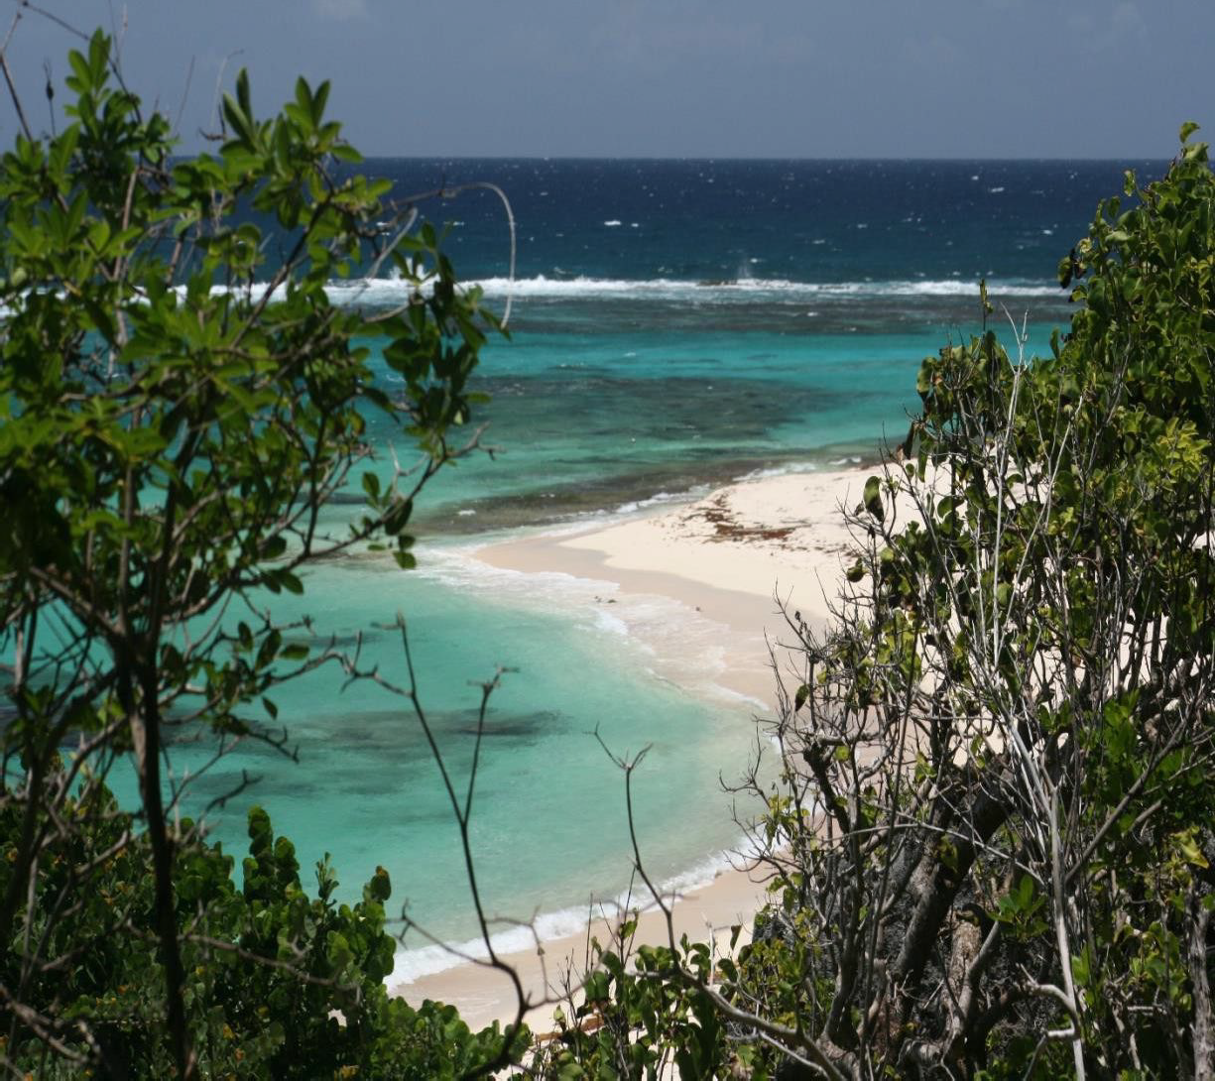

PRIVACY RIGHTS

The College adheres to the mandates of the United States Family Educational Rights and Privacy Act (FERPA):

- The student has the right to inspect and review his educational record within 45 days of the College receiving a written request for access. Students must submit this written request to the Dean and Registrar identifying the records they wish to inspect. The Dean and Registrar will notify the student of the time and place where the record may be inspected.

- Students have the right to request the amendment of their educational records. Students may write to the Dean and Registrar to identify the part of the record they wish to have corrected and specify why it is inaccurate.

- If the College decides not to make the requested amendment, it notifies the student and advises the student of his/her right to a hearing. The College provides additional information about the hearing with the notification.

- The student has the right to consent to disclosures of personally identifiable information contained in his/her educational record, except to the extent that FERPA authorizes disclosure without consent.

One exception is disclosure to school officials with legitimate educational interest. A school official is a person employed by the College in an administrative, supervisory, academic, research or support position (including law enforcement personnel and health staff); a person or company with whom the College has contracted (such as an attorney, auditor, or collection agent); a person serving on the Board of Trustees; or a student serving on an official committee, such as Disciplinary or Grievance Committee, or assisting another school official in performing his tasks.

A school official has a legitimate educational interest if she/he needs to review an educational record to fulfill his/her professional responsibility. Upon request, the College may disclose directory information from educational records without consent to officials of another school in which a student seeks to enroll or attend.

INFORMATION TO BE DISCLOSED

The College may disclose the following “directory” information without prior approval from the student: Name, address, and telephone number; Date and place of birth; and Dates of attendance, honors and awards. A student who does not wish to have the previously listed information released must advise the school in writing accordingly.

A student has the right to file a complaint with the U.S. Department of Education concerning alleged failures by the College to comply with FERPA requirements at the below address:

Family Policy Compliance Office
U.S. Department of Education 400 Maryland Avenue, SW Washington, DC 20202-4605

